Source Code – (PA9.cpp)  
  
#include <iostream>

#include <stdio.h>

#include <stdlib.h>

#include <string.h>

#include <math.h>

#include <fftw3.h> // FFTW library for CPU FFT

#include <cufft.h> // cuFFT library for GPU FFT

#include <cuda_runtime.h> // CUDA runtime API

#include <chrono> // For timing

#include "WavFile.h" // Make sure WavFile.h and WavFile.cpp are present

#define BUFF_SIZE 16384 // Processing buffer size in samples

#define MAX_FREQ 48 // KHz (Used if power analysis is added back)

using namespace std;

// Macro for checking CUDA errors

#define CUDA_CHECK(ans) { gpuAssert((ans), __FILE__, __LINE__); }

inline void gpuAssert(cudaError_t code, const char *file, int line, bool abort = true) {

// Function to check CUDA API call results and report errors

if (code != cudaSuccess) {

fprintf(stderr, "GPUassert: %s %s %d\n", cudaGetErrorString(code), file, line);

if (abort)

exit(code); // Exit if the error is critical

}

}

// --- Helper Function for Filtering (CPU) ---

// This function modifies the complex frequency data in place.

// It zeros out frequency bins around a target frequency.

void filterFrequencyDomain(fftw_complex* data, int N, double sampleRate, double freqToFilter, int /*filterWidth*/) {

// Compute the bin corresponding to freqToFilter

int target_bin = static_cast<int>(freqToFilter * N / sampleRate);

// Mirror index for the negative‐frequency component

int mirror_bin = N - target_bin;

printf("Zeroing bins %d, %d (positive and negative %.2f Hz)\n", target_bin, mirror_bin, freqToFilter);

// Make sure we can safely zero target_bin, target_bin+1, and mirror_bin-1

if (target_bin >= 0 && target_bin + 1 < N && mirror_bin - 1 >= 0) {

// Positive‐frequency bins

data[target_bin][0] = 0.0; // real

data[target_bin][1] = 0.0; // imag

data[target_bin + 1][0] = 0.0;

data[target_bin + 1][1] = 0.0;

// Negative‐frequency bins (mirror)

data[mirror_bin][0] = 0.0;

data[mirror_bin][1] = 0.0;

data[mirror_bin - 1][0] = 0.0;

data[mirror_bin - 1][1] = 0.0;

}

}

int main(int argc, char *argv[]) {

const char *wavfile; // input wav file path

wavfile = argv[1];

char *base_name = strdup(wavfile);

char *dot = strrchr(base_name, '.');

if (dot && !strcmp(dot, ".wav")) {

*dot = '\0';

}

char *wavfileout_cpu = (char *)malloc(strlen(base_name) + strlen("_cpu_out.wav") + 1);

char *wavfileout_gpu = (char *)malloc(strlen(base_name) + strlen("_gpu_out.wav") + 1);

char *logfile = (char *)malloc(strlen(base_name) + strlen("_out.log") + 1);

if (!wavfileout_cpu || !wavfileout_gpu || !logfile) { // Check allocation success

fprintf(stderr, "Error allocating memory for filenames.\n");

free(base_name);

exit(1);

}

sprintf(wavfileout_cpu, "%s_cpu_out.wav", base_name);

sprintf(wavfileout_gpu, "%s_gpu_out.wav", base_name);

sprintf(logfile, "%s_out.log", base_name);

printf("Input WAV file: %s\n", wavfile);

printf("CPU Output WAV file: %s\n", wavfileout_cpu);

printf("GPU Output WAV file: %s\n", wavfileout_gpu);

printf("Log file: %s\n", logfile);

free(base_name); // Free the duplicated base name now that filenames are constructed

fftw_complex *h_fft_in, *h_fft_out_cpu, *h_ifft_out_cpu; // Host buffers for CPU path

h_fft_in = (fftw_complex*) fftw_malloc(sizeof(fftw_complex) * BUFF_SIZE);

h_fft_out_cpu = (fftw_complex*) fftw_malloc(sizeof(fftw_complex) * BUFF_SIZE);

h_ifft_out_cpu = (fftw_complex*) fftw_malloc(sizeof(fftw_complex) * BUFF_SIZE);

fftw_complex *h_fft_out_gpu_temp; // Host buffer to hold GPU FFT result for CPU filtering

h_fft_out_gpu_temp = (fftw_complex*) fftw_malloc(sizeof(fftw_complex) * BUFF_SIZE);

if (!h_fft_in || !h_fft_out_cpu || !h_ifft_out_cpu || !h_fft_out_gpu_temp) {

fprintf(stderr, "Error allocating FFTW host memory.\n");

fftw_free(h_fft_in); fftw_free(h_fft_out_cpu); fftw_free(h_ifft_out_cpu); fftw_free(h_fft_out_gpu_temp);

free(wavfileout_cpu); free(wavfileout_gpu); free(logfile);

exit(1);

}

fftw_plan plan_forward_cpu = fftw_plan_dft_1d(BUFF_SIZE, h_fft_in, h_fft_out_cpu, FFTW_FORWARD, FFTW_ESTIMATE);

fftw_plan plan_backward_cpu = fftw_plan_dft_1d(BUFF_SIZE, h_fft_out_cpu, h_ifft_out_cpu, FFTW_BACKWARD, FFTW_ESTIMATE);

cufftHandle plan_forward_gpu, plan_backward_gpu;

cufftDoubleComplex *d_fft_data;

cufftDoubleComplex *h_ifft_out_gpu; // Host buffer for final GPU IFFT result

int nx = BUFF_SIZE;

int batch = 1;

cufftType type = CUFFT_Z2Z;

CUDA_CHECK(cudaMalloc((void**)&d_fft_data, nx * sizeof(cufftDoubleComplex)));

h_ifft_out_gpu = (cufftDoubleComplex *)calloc(nx, sizeof(cufftDoubleComplex));

if (!h_ifft_out_gpu) {

fprintf(stderr, "Error allocating host memory for cuFFT output.\n");

cudaFree(d_fft_data);

fftw_free(h_fft_in); fftw_free(h_fft_out_cpu); fftw_free(h_ifft_out_cpu); fftw_free(h_fft_out_gpu_temp);

fftw_destroy_plan(plan_forward_cpu); fftw_destroy_plan(plan_backward_cpu);

free(wavfileout_cpu); free(wavfileout_gpu); free(logfile);

exit(1);

}

cufftResult status;

status = cufftPlan1d(&plan_forward_gpu, nx, type, batch);

if (status != CUFFT_SUCCESS) {

printf("error: cufftPlan1d (forward GPU) failed.\n");

cudaFree(d_fft_data); free(h_ifft_out_gpu);

fftw_free(h_fft_in); fftw_free(h_fft_out_cpu); fftw_free(h_ifft_out_cpu); fftw_free(h_fft_out_gpu_temp);

fftw_destroy_plan(plan_forward_cpu); fftw_destroy_plan(plan_backward_cpu);

free(wavfileout_cpu); free(wavfileout_gpu); free(logfile);

exit(1);

}

status = cufftPlan1d(&plan_backward_gpu, nx, type, batch);

if (status != CUFFT_SUCCESS) { /* ... error handling & cleanup ... */

printf("error: cufftPlan1d (backward GPU) failed.\n");

cufftDestroy(plan_forward_gpu);

cudaFree(d_fft_data); free(h_ifft_out_gpu);

fftw_free(h_fft_in); fftw_free(h_fft_out_cpu); fftw_free(h_ifft_out_cpu); fftw_free(h_fft_out_gpu_temp);

fftw_destroy_plan(plan_forward_cpu); fftw_destroy_plan(plan_backward_cpu);

free(wavfileout_cpu); free(wavfileout_gpu); free(logfile);

exit(1);

}

// --- Audio File Handling ---

short sampleBuffer[BUFF_SIZE]; // Buffer to read samples from input WAV

short outputBufferCpu[BUFF_SIZE]; // Output buffer for CPU path results

short outputBufferGpu[BUFF_SIZE]; // Output buffer for GPU path results

WavInFile inFile(wavfile);

printf("--- Input WAV File Info ---\n");

printf("SampleRate: %d Hz\n", inFile.getSampleRate());

printf("BitsPerSample: %d\n", inFile.getNumBits());

printf("NumChannels: %d\n", inFile.getNumChannels());

printf("NumSamples: %u\n", inFile.getNumSamples());

printf("---------------------------\n");

if (inFile.getNumChannels() != 1) { /* ... error handling & cleanup ... */

fprintf(stderr, "Error: Input file must be mono.\n");

cufftDestroy(plan_forward_gpu); cufftDestroy(plan_backward_gpu);

cudaFree(d_fft_data); free(h_ifft_out_gpu);

fftw_free(h_fft_in); fftw_free(h_fft_out_cpu); fftw_free(h_ifft_out_cpu); fftw_free(h_fft_out_gpu_temp);

fftw_destroy_plan(plan_forward_cpu); fftw_destroy_plan(plan_backward_cpu);

free(wavfileout_cpu); free(wavfileout_gpu); free(logfile);

exit(1);

}

if (inFile.getNumBits() != 16) {

fprintf(stderr, "Warning: Input file is not 16-bit. Output will be 16-bit.\n");

}

// Create output WAV file objects for both CPU and GPU paths

WavOutFile outFileCpu(wavfileout_cpu, inFile.getSampleRate(), 16, 1);

WavOutFile outFileGpu(wavfileout_gpu, inFile.getSampleRate(), 16, 1);

FILE *log_fp;

if ((log_fp = fopen(logfile, "w")) == NULL) { /* ... error handling & cleanup ... */

fprintf(stderr, "can't open %s for writing\n", logfile);

cufftDestroy(plan_forward_gpu); cufftDestroy(plan_backward_gpu);

cudaFree(d_fft_data); free(h_ifft_out_gpu);

fftw_free(h_fft_in); fftw_free(h_fft_out_cpu); fftw_free(h_ifft_out_cpu); fftw_free(h_fft_out_gpu_temp);

fftw_destroy_plan(plan_forward_cpu); fftw_destroy_plan(plan_backward_cpu);

free(wavfileout_cpu); free(wavfileout_gpu); free(logfile);

// Note: WavOutFile destructors will handle closing if objects were created

exit(1);

}

// --- Timing Variables ---

long long total_cpu_path_duration_us = 0;

long long total_gpu_path_duration_us = 0;

int chunk_count = 0;

double sampleRate = inFile.getSampleRate();

double freqToFilter = 10000.0;

int filterWidth = 2;

printf("\nStarting audio processing...\n");

while (!inFile.eof()) {

size_t samplesRead = inFile.read(sampleBuffer, BUFF_SIZE);

if (samplesRead == 0) break;

chunk_count++;

for (size_t i = 0; i < BUFF_SIZE; ++i) {

if (i < samplesRead) {

h_fft_in[i][0] = (double)sampleBuffer[i];

h_fft_in[i][1] = 0.0;

} else {

h_fft_in[i][0] = 0.0;

h_fft_in[i][1] = 0.0;

}

}

auto start_cpu_path = chrono::high_resolution_clock::now();

// 1. FFTW Forward FFT (CPU)

fftw_execute(plan_forward_cpu);

// 2. Filter on CPU

filterFrequencyDomain(h_fft_out_cpu, BUFF_SIZE, sampleRate, freqToFilter, filterWidth);

// 3. FFTW Inverse FFT (CPU)

fftw_execute(plan_backward_cpu);

auto stop_cpu_path = chrono::high_resolution_clock::now();

// 4. Prepare CPU Output Buffer

for (size_t i = 0; i < samplesRead; ++i) {

// Normalize FFTW IFFT output by dividing by N (BUFF_SIZE)

double real_part = h_ifft_out_cpu[i][0] / BUFF_SIZE;

// Clamp values to the 16-bit signed integer range

if (real_part > 32767.0) real_part = 32767.0;

else if (real_part < -32768.0) real_part = -32768.0;

// Cast to short for output

outputBufferCpu[i] = (short)real_part;

}

total_cpu_path_duration_us += chrono::duration_cast<std::chrono::microseconds>(stop_cpu_path - start_cpu_path).count();

// 1. Copy input data Host -> Device

CUDA_CHECK(cudaMemcpy(d_fft_data, (cufftDoubleComplex*)h_fft_in, nx * sizeof(cufftDoubleComplex), cudaMemcpyHostToDevice));

// 2. cuFFT Forward FFT (GPU)

auto start_gpu_path = chrono::high_resolution_clock::now();

status = cufftExecZ2Z(plan_forward_gpu, d_fft_data, d_fft_data, CUFFT_FORWARD);

if (status != CUFFT_SUCCESS) { /* ... error handling & cleanup ... */

printf("error: cufftExecZ2Z (forward GPU) failed.\n");

cudaFree(d_fft_data); free(h_ifft_out_gpu); cufftDestroy(plan_forward_gpu); cufftDestroy(plan_backward_gpu);

fftw_free(h_fft_in); fftw_free(h_fft_out_cpu); fftw_free(h_ifft_out_cpu); fftw_free(h_fft_out_gpu_temp);

fftw_destroy_plan(plan_forward_cpu); fftw_destroy_plan(plan_backward_cpu); fclose(log_fp);

free(wavfileout_cpu); free(wavfileout_gpu); free(logfile);

exit(1);

}

// 3. Copy FFT result Device -> Host (Temp buffer)

CUDA_CHECK(cudaMemcpy((cufftDoubleComplex*)h_fft_out_gpu_temp, d_fft_data, nx * sizeof(cufftDoubleComplex), cudaMemcpyDeviceToHost));

// 4. Filter on CPU (using the data copied back from GPU)

filterFrequencyDomain(h_fft_out_gpu_temp, BUFF_SIZE, sampleRate, freqToFilter, filterWidth);

// 5. Copy Filtered data Host (Temp buffer) -> Device

CUDA_CHECK(cudaMemcpy(d_fft_data, (cufftDoubleComplex*)h_fft_out_gpu_temp, nx * sizeof(cufftDoubleComplex), cudaMemcpyHostToDevice));

// 6. cuFFT Inverse FFT (GPU)

status = cufftExecZ2Z(plan_backward_gpu, d_fft_data, d_fft_data, CUFFT_INVERSE);

if (status != CUFFT_SUCCESS) { /* ... error handling & cleanup ... */

printf("error: cufftExecZ2Z (inverse GPU) failed.\n");

cudaFree(d_fft_data); free(h_ifft_out_gpu); cufftDestroy(plan_forward_gpu); cufftDestroy(plan_backward_gpu);

fftw_free(h_fft_in); fftw_free(h_fft_out_cpu); fftw_free(h_ifft_out_cpu); fftw_free(h_fft_out_gpu_temp);

fftw_destroy_plan(plan_forward_cpu); fftw_destroy_plan(plan_backward_cpu); fclose(log_fp);

free(wavfileout_cpu); free(wavfileout_gpu); free(logfile);

exit(1);

}

auto stop_gpu_path = chrono::high_resolution_clock::now();

// 7. Copy final result Device -> Host

CUDA_CHECK(cudaMemcpy(h_ifft_out_gpu, d_fft_data, nx * sizeof(cufftDoubleComplex), cudaMemcpyDeviceToHost));

// 8. Synchronize before stopping timer

CUDA_CHECK(cudaDeviceSynchronize());

total_gpu_path_duration_us += chrono::duration_cast<std::chrono::microseconds>(stop_gpu_path - start_gpu_path).count();

// --- Prepare GPU Output Buffer ---

for (size_t i = 0; i < samplesRead; ++i) {

// Normalize cuFFT IFFT output

double real_part = h_ifft_out_gpu[i].x / nx;

// Clamp values

if (real_part > 32767.0) real_part = 32767.0;

else if (real_part < -32768.0) real_part = -32768.0;

// Cast to short

outputBufferGpu[i] = (short)real_part;

}

// --- Write Outputs ---

outFileCpu.write(outputBufferCpu, samplesRead); // Write CPU path result

outFileGpu.write(outputBufferGpu, samplesRead); // Write GPU path result

} // End while loop

printf("\nProcessing finished. Processed %d chunks.\n", chunk_count);

// --- Timing Results ---

if (chunk_count > 0) {

double avg_cpu_ms = (double)total_cpu_path_duration_us / chunk_count / 1000.0;

double avg_gpu_ms = (double)total_gpu_path_duration_us / chunk_count / 1000.0;

printf("\n--- Timing Comparison (Average per %d-sample chunk) ---\n", BUFF_SIZE);

printf("CPU Path (FFTW Fwd + CPU Filter + FFTW Inv + Prepare Output): %.4f ms\n", avg_cpu_ms);

printf("GPU Path (H->D + cuFFT Fwd + D->H + CPU Filter + H->D + cuFFT Inv + D->H + Sync + Prepare Output): %.4f ms\n", avg_gpu_ms);

printf("--------------------------------------------------------\n");

fprintf(log_fp, "Processed %d chunks of size %d.\n", chunk_count, BUFF_SIZE);

fprintf(log_fp, "Filter Target: %.1f Hz, Width: %d bins\n", freqToFilter, filterWidth);

fprintf(log_fp, "Average CPU Path time per chunk: %.4f ms\n", avg_cpu_ms);

fprintf(log_fp, "Average GPU Path time per chunk: %.4f ms\n", avg_gpu_ms);

fprintf(log_fp, "CPU output saved to: %s\n", wavfileout_cpu);

fprintf(log_fp, "GPU output saved to: %s\n", wavfileout_gpu);

} else {

printf("\nNo data processed, skipping timing results.\n");

fprintf(log_fp, "No data processed.\n");

}

fftw_destroy_plan(plan_forward_cpu);

fftw_destroy_plan(plan_backward_cpu);

fftw_free(h_fft_in);

fftw_free(h_fft_out_cpu);

fftw_free(h_ifft_out_cpu);

fftw_free(h_fft_out_gpu_temp);

cufftDestroy(plan_forward_gpu);

cufftDestroy(plan_backward_gpu);

cudaFree(d_fft_data);

free(h_ifft_out_gpu);

fclose(log_fp);

free(wavfileout_cpu);

free(wavfileout_gpu);

free(logfile);

return 0;

}  
  
**I used majority of the source provided by Professor with additional benchmarking and attenuation code. Additionally, I dislike using std:: so used namespace std. Apart from that source code is similar to the one provided.  
  
SPECTOGRAM**

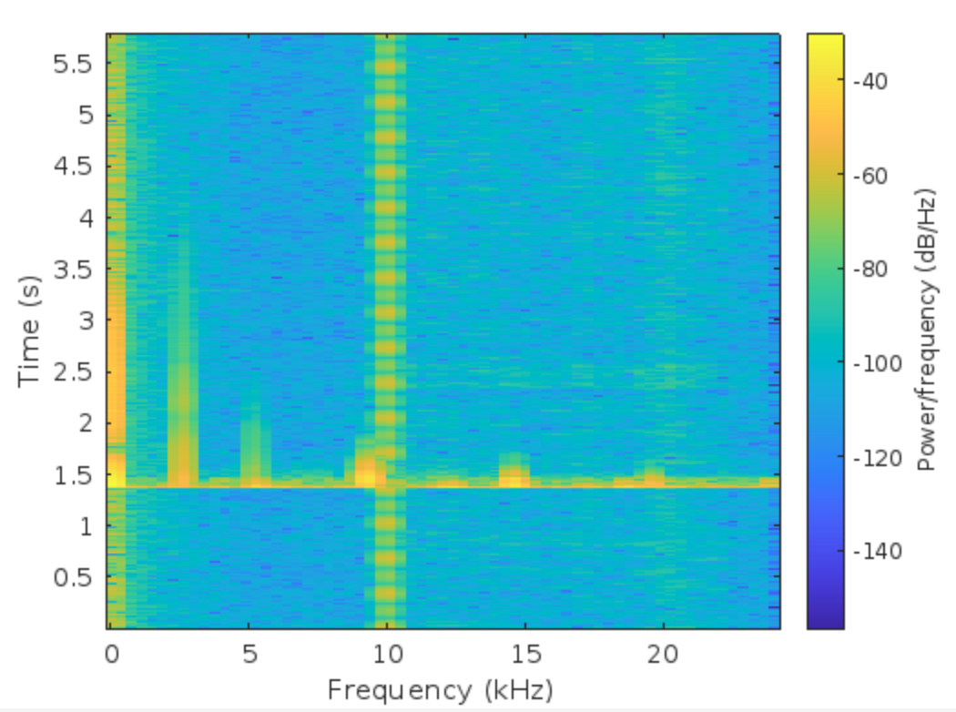

As seen in spectrogram there is a vertical blue line at 10Khz indicating that the required frequency was attenuated. Neighboring frequencies are still visible (9.5khz, 10.5 Khz) because we are using 2 bins and each bin spans 2.93 Hz ( Fs/N per bin).

**Timings**

Average CPU Path time per chunk: 0.2391 ms

Average GPU Path time per chunk: 0.1696 ms  
  
**Discussion**  
  
Initially, I was getting higher timing for GPU but I realized that’s because I was calculating data transfer (Device -> Host and back to Device). After reading prompt carefully, I used benchmarking only for the forward and inverse Fourier transform calculations resulting in more consistent results.